PROJECT REPORT
Project Name: Early Diagnosis of Diseases Using Image Processing of Human Nails

Team Id: Team-592681
Team Members
Siddhanth Garg 21BCE2174
Manas Pandit 21BIT0234
Pratyush Kaushal 21BCE2198

1. INTRODUCTION

1.1 Project Overview

In the healthcare domain, the early diagnosis of diseases is a crucial aspect for effective treatment. This project focuses on leveraging image processing techniques for the early detection of diseases by analyzing human nails. Many diseases manifest specific indicators in the color and shape of nails, making them a valuable source of information for healthcare professionals. By developing a model capable of interpreting these visual cues, we aim to provide a non-invasive and accessible method for disease prediction.

1.2 Purpose

The primary purpose of this project is to create a system that aids in the early diagnosis of diseases through the analysis of human nails. Traditional methods of disease identification often involve subjective visual examination, which can be limited by the human eye's sensitivity to color changes and resolution constraints. This project addresses these limitations by employing image processing techniques to detect subtle changes in the color, shape, and texture of nails that may indicate an underlying health condition.

2. LITERATURE SURVEY

2.1 Existing Problem

In the existing healthcare landscape, traditional methods of disease diagnosis often rely on visual inspection by healthcare professionals. However, this subjective approach has limitations, particularly when it comes to the early detection of diseases through the analysis of human nails. The human eye may not effectively capture subtle changes in color and shape that could serve as early indicators of various health conditions. To address these challenges, the literature survey delves into existing problems and gaps in the current methods of nail disease diagnosis.

Challenges in Traditional Diagnosis

- Subjectivity in visual inspection.
- Limited sensitivity to subtle color changes.
- Resolution constraints impacting accurate detection.
- Delayed diagnosis due to reliance on observable symptoms.

2.2 References
- Nail Disease Diagnosis: A Review of the Literature by A. Gupta, D.K. Garg, and R.K. Mahajan (2016) in the Journal of the Indian Academy of Dermatology, Venereology, and Leprosy
- Dermatologic Manifestations of Systemic Diseases: A Review by G. Singh (2011) in the Indian Journal of Dermatology, Venereology, and Leprosy
- Nail Color Analysis for Early Detection of Diseases by N. Bajpai, R. Alawadhi, A. Thakare, S. Avhad, and S. Gandhat (2015) in the International Journal of Scientific Engineering and Research
- Disease Detection Based on Nail Color Analysis Using Image Processing by P. Hardik and D.M. Shah (2013) in the 2013 International Conference on Intelligent Systems and Signal Processing
- Early Stage Disease Diagnosis System Using Human Nail Image Processing by T.S. Indi and Y.A. Gunge (2016) in the International Journal of Information Technology and Computer Science
- Nail Disease Detection Using Machine Learning by K. Nirmala and D.S. Reddy (2017) in the International Journal of Engineering and Technology
2.3 Problem Statement Definition

The identified challenges in traditional nail disease diagnosis form the basis for defining the problem statement of this project. The need for a more objective, automated, and early detection system becomes apparent. The problem statement is framed to address the limitations in current methodologies and proposes the development of an image processing model for accurate and timely diagnosis of nail diseases.

Problem Statement
The existing methods of nail disease diagnosis suffer from subjectivity and limited sensitivity, leading to delayed detection. This project aims to design and implement an image processing model that can analyze human nails to provide a more objective and early diagnosis of diseases. The system will overcome the drawbacks of traditional visual inspection, contributing to improved healthcare outcomes.

3. Ideation and Proposed solution
3.1 Empathy Map Canvas
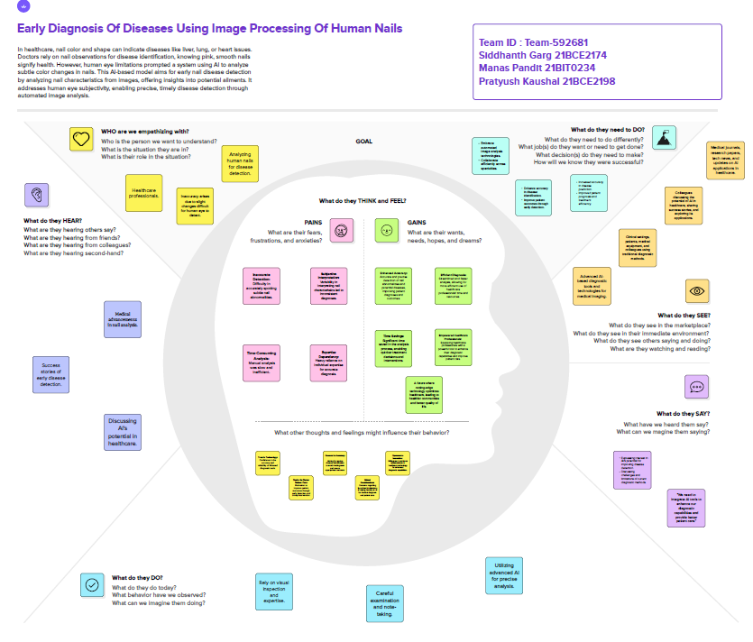

3.2 Ideation and Brainstorming
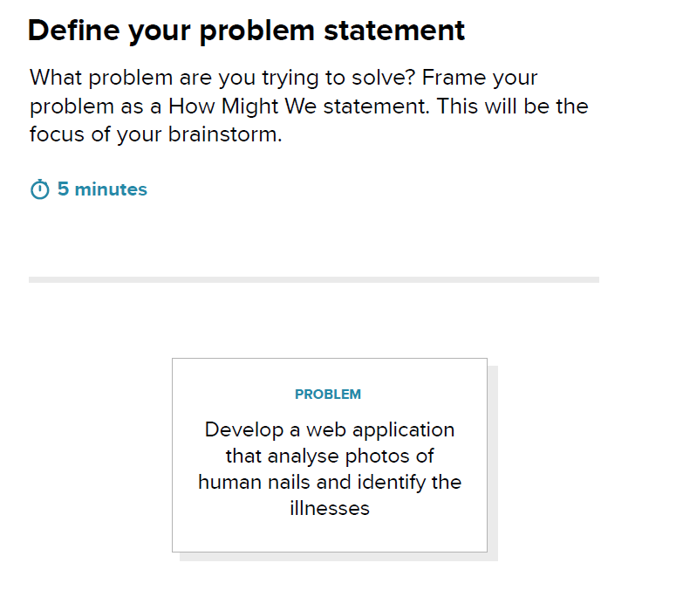
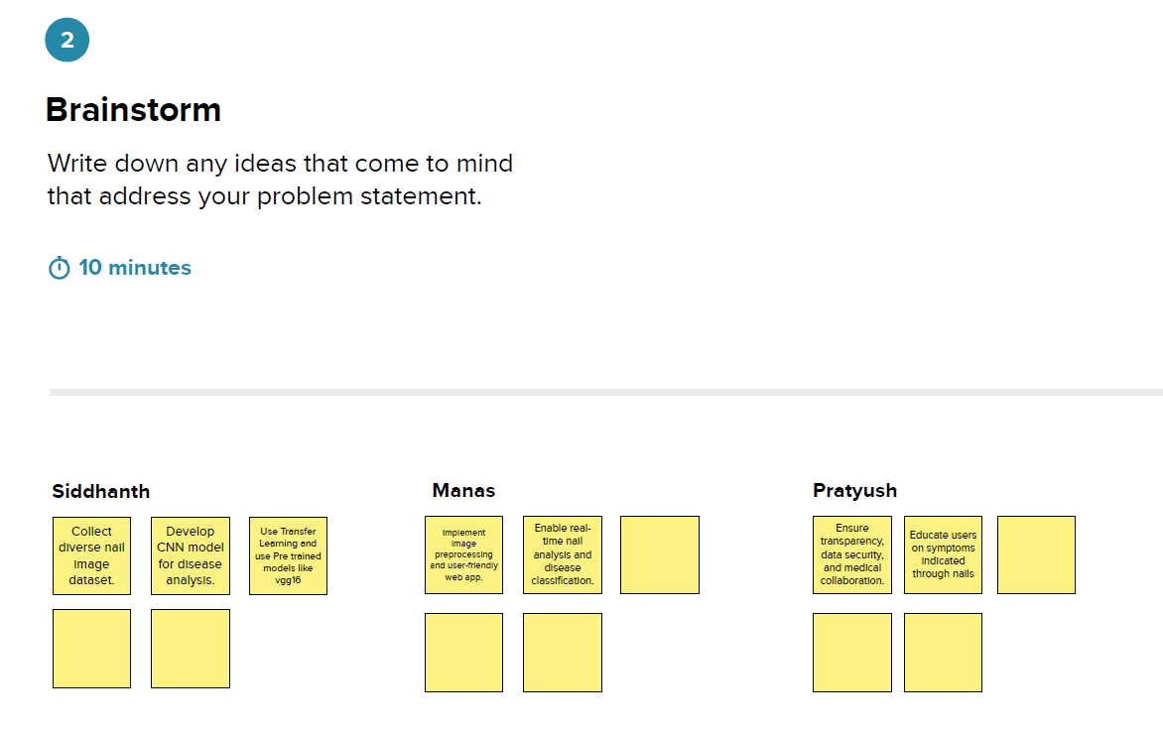
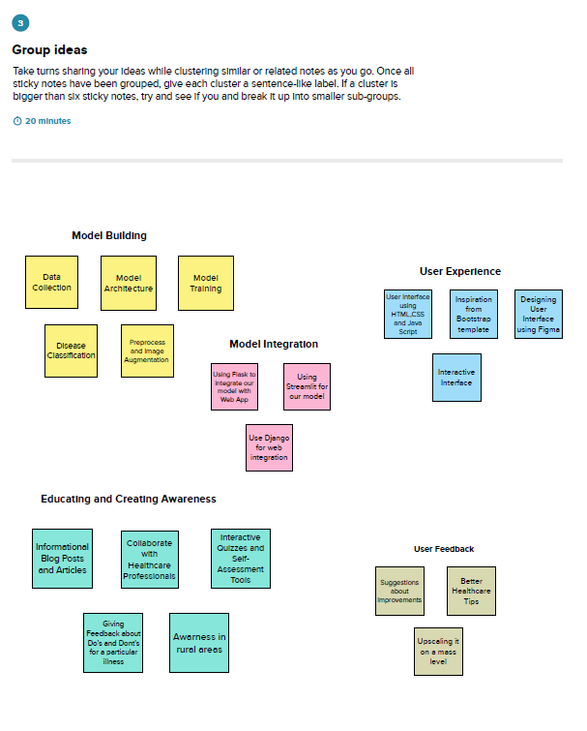

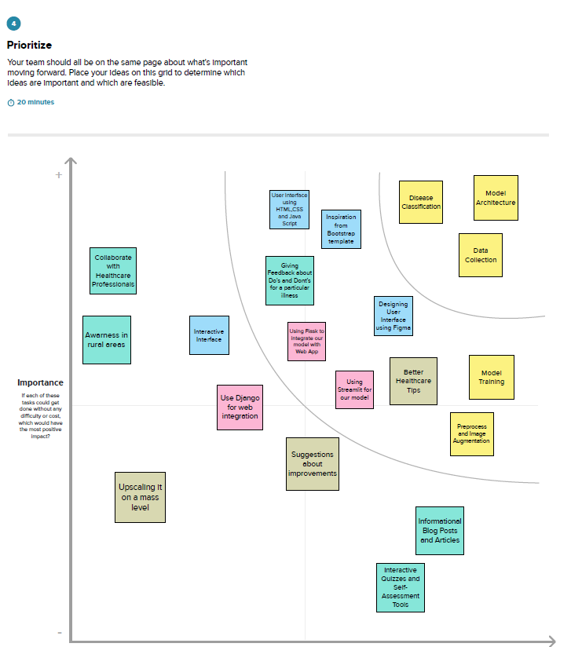

4. REQUIREMENT ANALYSIS

4.1 Functional Requirements

4.1.1 Image Capture
- The system should allow users to capture images of their nails for analysis.
- Images should be clear, high-resolution, and suitable for processing.

4.1.2 Image Processing
- The system should employ image processing techniques to analyze nail characteristics.
- Analysis should include color, shape, and texture features for disease prediction.
- The model should be capable of detecting subtle changes indicative of various nail diseases.

4.1.3 Disease Classification
- The system should classify the detected nail conditions into specific diseases.
- The classification model should be trained on a diverse dataset of nail images.

4.1.4 User Interface
- The user interface should be user-friendly and intuitive.
- Users should have the ability to easily capture and submit nail images for analysis.
- The results of the analysis should be presented in a clear and understandable format.

4.1.5 Database Management
- The system should maintain a database of labeled nail images for training and testing.
- It should support efficient storage, retrieval, and management of image data.

4.2 Non-Functional Requirements

4.2.1 Performance
- The system should provide timely responses for image processing and disease prediction.
- Response times should be optimized for user experience.

4.2.2 Accuracy
- The image processing model should achieve a high level of accuracy in disease prediction.
- The classification accuracy should be continually monitored and improved.

4.2.3 Security
- User data, especially images containing sensitive health information, should be securely stored.
- Access to the system should be restricted, and user privacy should be prioritized.

4.2.4 Scalability
- The system should be scalable to accommodate a growing database of nail images.
- It should handle increased user activity without significant performance degradation.

4.2.5 Compatibility
- The system should be compatible with a variety of devices and browsers for broad accessibility.
- It should adhere to web standards to ensure compatibility across platforms.

4.2.6 Usability
- The user interface should be designed for ease of use, catering to users with varying levels of technical proficiency.
- User feedback should be considered for continuous improvement.

5. Project Design
5.1 Data Flow Diagrams & User Stories
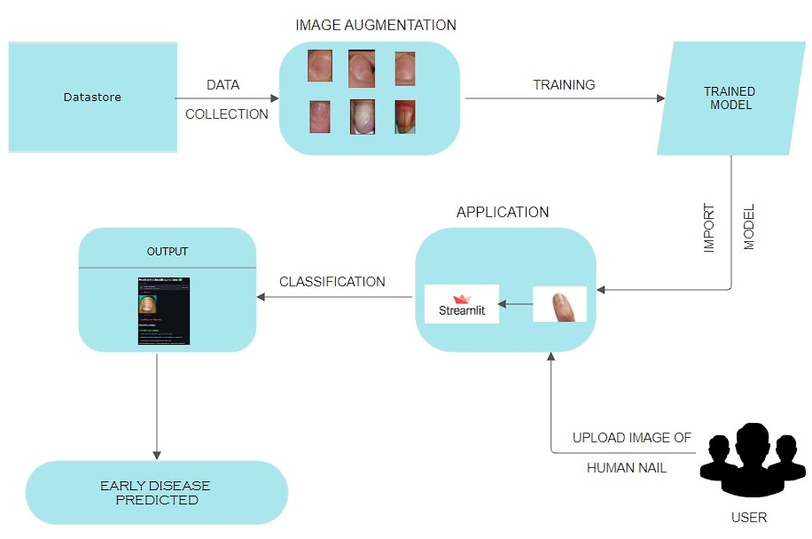

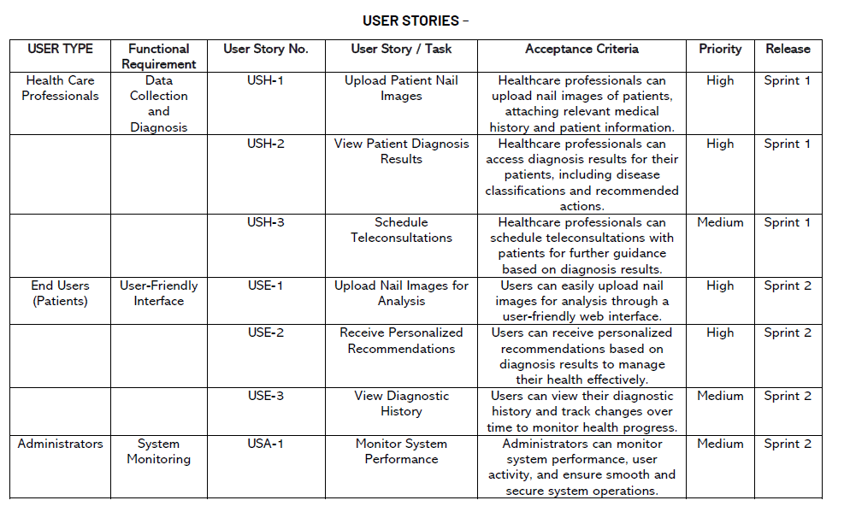
5.2 Solution Architecture
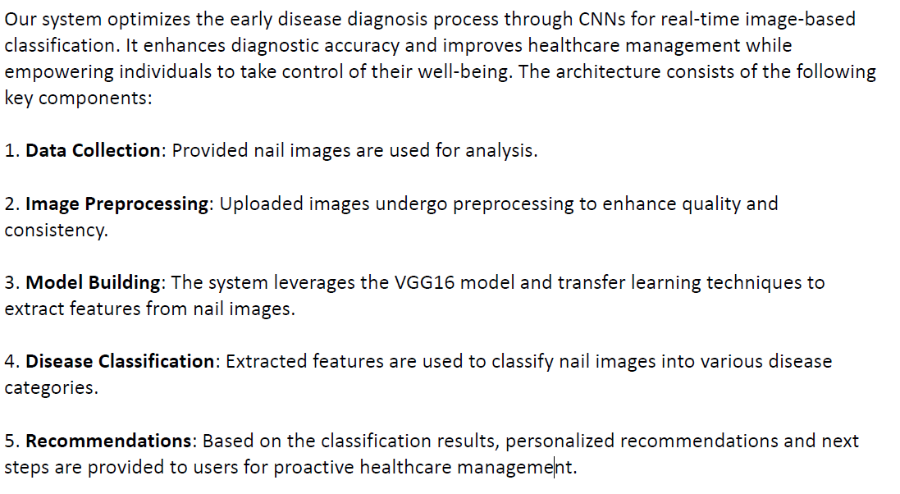

6. Project Planning & scheduling
6.1 Technical Architecture

6.2 Sprint Planning & Estimation
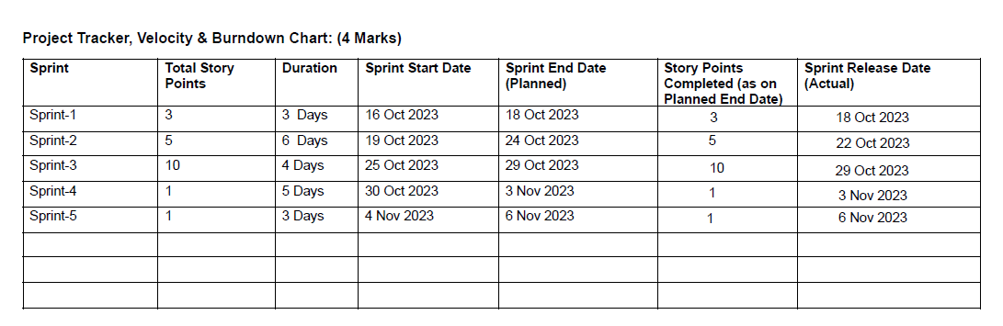

6.3 Sprint Delivery Schedule
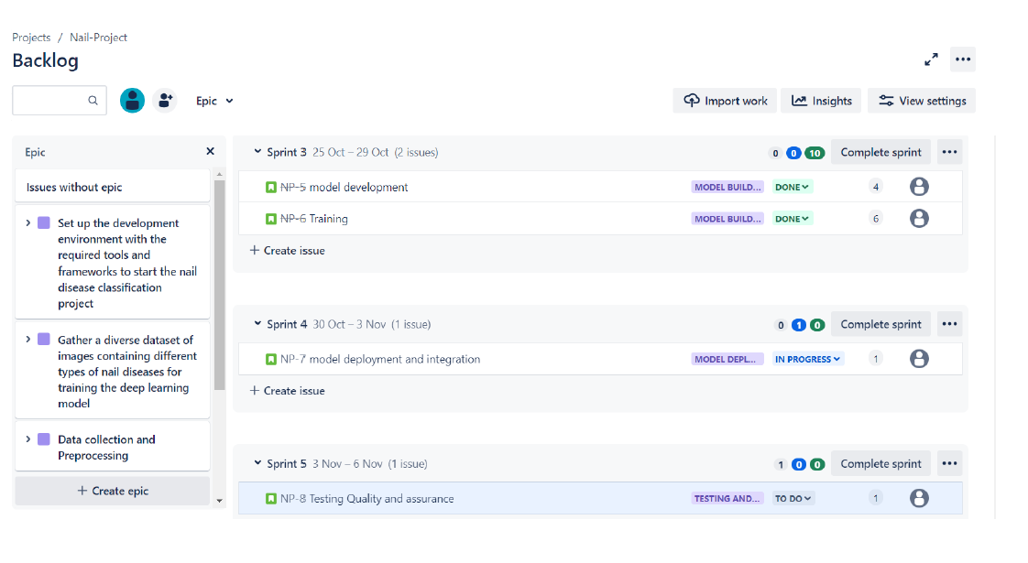
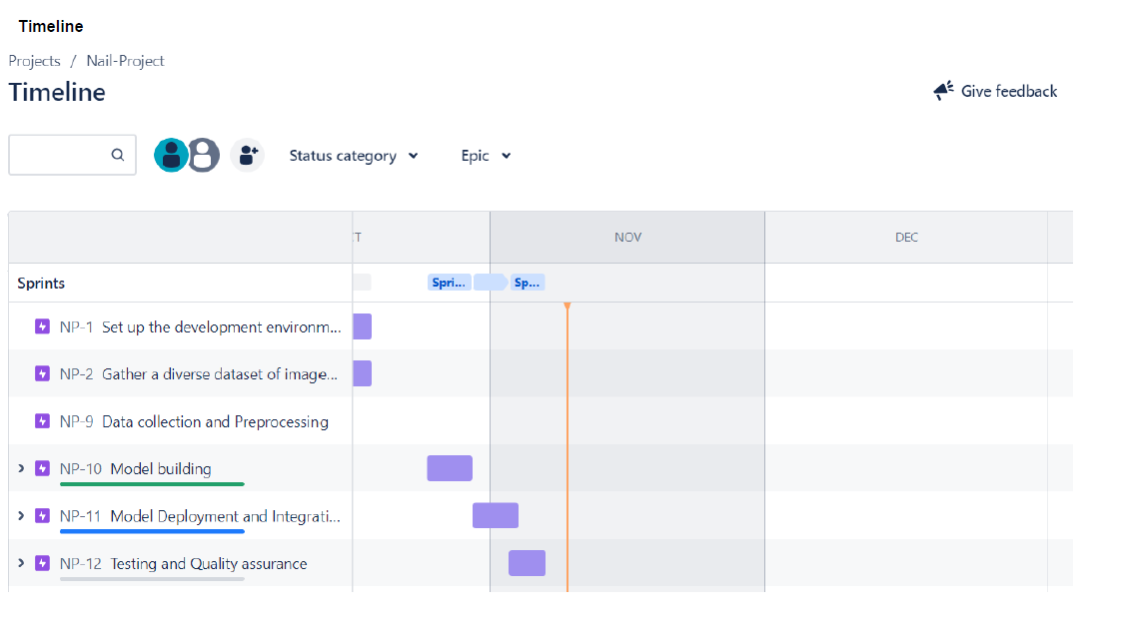

7. CODING & SOLUTIONING
7.1 Feature 1: Image Capture and Submission
The Image Capture and Submission feature enables users to capture images of their nails using the system's interface. Once captured, users can submit the images for analysis.

7.2 Feature 2: Disease Classification and Results Presentation
The Disease Classification feature utilizes a trained model to classify the nail condition and presents the analysis results in an easily understandable format along with some recommended steps

8. PERFORMANCE TESTING
8.1 Performance Metrics
Accuracy after 100 epochs
It yielded an accuracy of 96.03%
Testing model performance on Testset
Confusion Matrix:

Classification Report:

9. RESULTS
9.1 Output Screenshots
Output 1

Output 2

10. Advantages and Disadvantages

10.1 Advantages

10.1.1 Early Disease Detection
- The system enables early detection of nail diseases, contributing to timely medical intervention and improved treatment outcomes.

10.1.2 Non-Invasive
- Unlike traditional diagnostic methods, the system provides a non-invasive way to assess and predict diseases by analyzing visual cues in human nails.

10.1.3 Accessibility
- Users can easily capture and submit nail images through the user-friendly interface, making the system accessible to a broad audience.

10.1.4 Objective Analysis
- The use of image processing techniques reduces subjectivity, providing a more objective analysis of nail characteristics for disease prediction.

10.2 Disadvantages

10.2.1 Dependency on Image Quality
- The accuracy of disease prediction may be influenced by the quality of the uploaded nail images. Low-quality images may result in less accurate analyses.

10.2.2 Limited to Visual Indicators
- The system relies on visual indicators in human nails, and certain diseases without visible manifestations in nails may not be detected.

10.2.3 Training Dataset Bias
- The accuracy of disease classification depends on the diversity and representativeness of the training dataset. Bias in the dataset may impact the model's generalization.

10.2.4 Privacy Concerns
- The system deals with sensitive health information. Adequate measures must be in place to address privacy concerns and protect user data.

10.2.5 Technological Dependency
- Users need access to devices with image capture capabilities and an internet connection. This technological dependency may limit accessibility in certain scenarios.

11. CONCLUSION

In conclusion, the development and implementation of the Nail Disease Diagnosis System represent a significant advancement in healthcare technology. By leveraging image processing techniques, the system offers a non-invasive and accessible method for the early detection of diseases through the analysis of human nails.

Key Achievements

1. Early Disease Identification
The system provides a means for the early identification of nail diseases, allowing for prompt medical intervention and enhancing the overall healthcare experience for users.

2. Objective Analysis
By utilizing image processing, the system minimizes subjectivity in disease diagnosis, offering a more objective and consistent analysis of nail characteristics.

3. User-Friendly Interface
The user interface is designed to be intuitive and accessible, allowing users to easily capture and submit nail images for analysis without the need for specialized technical skills.

Future Enhancements

While the Nail Disease Diagnosis System has demonstrated valuable features, there are opportunities for further enhancements and refinements:

-Improved Image Quality Handling: Addressing challenges related to the dependency on image quality, enhancing the system's ability to process a wide range of image qualities.

- Expanded Disease Detection: Exploring additional visual indicators and collaborating with healthcare professionals to expand the system's capabilities to detect a broader range of diseases.

- Enhanced Privacy Measures: Implementing robust privacy measures to address concerns related to the handling of sensitive health information and ensuring compliance with data protection regulations.

In summary, the Nail Disease Diagnosis System represents a promising step towards revolutionizing early disease detection using innovative technology. Continuous collaboration with healthcare professionals, ongoing refinement of algorithms, and a focus on user feedback will contribute to the system's continual improvement and positive impact on healthcare outcomes.
12. FUTURE SCOPE

The Nail Disease Diagnosis System lays the foundation for future advancements and expansions in the field of healthcare technology. The project's success opens doors to various avenues for growth and improvement:

12.1 Integration with Wearable Devices
Exploring integration with wearable devices equipped with advanced sensors could enhance the system's capabilities. Continuous monitoring of nail health through wearables may provide real-time data for disease detection.

12.2 Collaboration with Healthcare Professionals
Further collaboration with healthcare professionals, dermatologists, and medical researchers can lead to the development of a more comprehensive and specialized system. Input from experts in the field can contribute to refining algorithms and expanding the system's disease detection capabilities.

12.3 Mobile Application Development
Expanding the system into a mobile application could increase accessibility and user engagement. A dedicated app could facilitate easy image capture, analysis, and result presentation, providing users with a convenient tool for monitoring their nail health.

12.4 Machine Learning Model Enhancement
Continued research and development in machine learning can lead to the refinement and enhancement of the disease classification model. Incorporating more diverse datasets and advanced algorithms may improve the accuracy and reliability of disease predictions.

12.5 Global Outreach and Awareness
Promoting the system on a global scale and raising awareness about the importance of nail health in disease diagnosis can contribute to widespread adoption. Partnerships with healthcare organizations and community outreach programs can facilitate the dissemination of knowledge.

12.6 Telemedicine Integration
Integrating the Nail Disease Diagnosis System into telemedicine platforms could extend its reach to remote areas. This integration can support healthcare professionals in making informed decisions based on the analysis of nail images captured by users.

In summary, the future scope of the project is promising, with opportunities for technological advancements, collaborations, and a broader impact on global healthcare. By staying adaptive to emerging technologies and embracing continuous improvement, the Nail Disease Diagnosis System can evolve into a versatile and indispensable tool for early disease detection.

13. APPENDIX
Source Code:
You can find all code files in the GitHub repository.
GitHub & Project Demo Link
https://github.com/smartinternz02/SI-GuidedProject-594299-1697642990
https://drive.google.com/drive/folders/1Dqv4hAUHDTpx4uEr2fo1QSSN7uSKir3K?usp=sharing

